Selenium IDE is record and playback tool- has many drawbacks.

Selenium webdriver- latest.

Selenium Grid- when we want to distribute test execution on multiple machines and browsers.

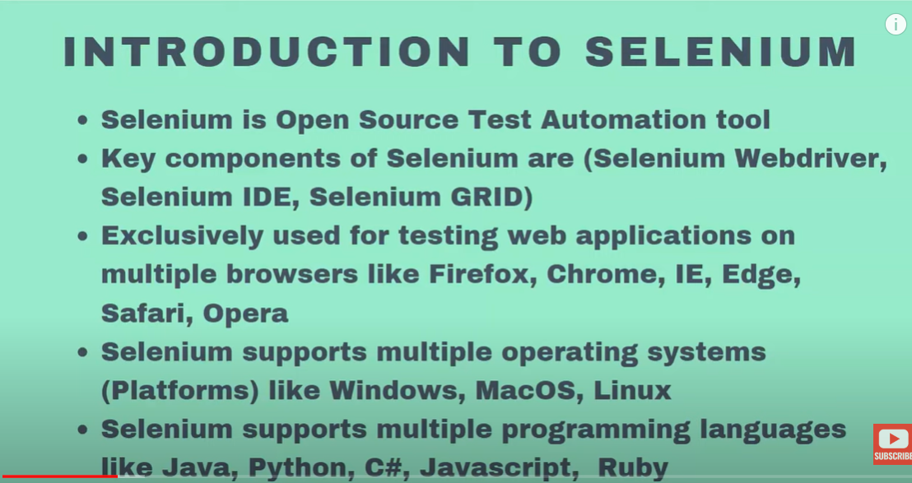

Selenium Architecture:

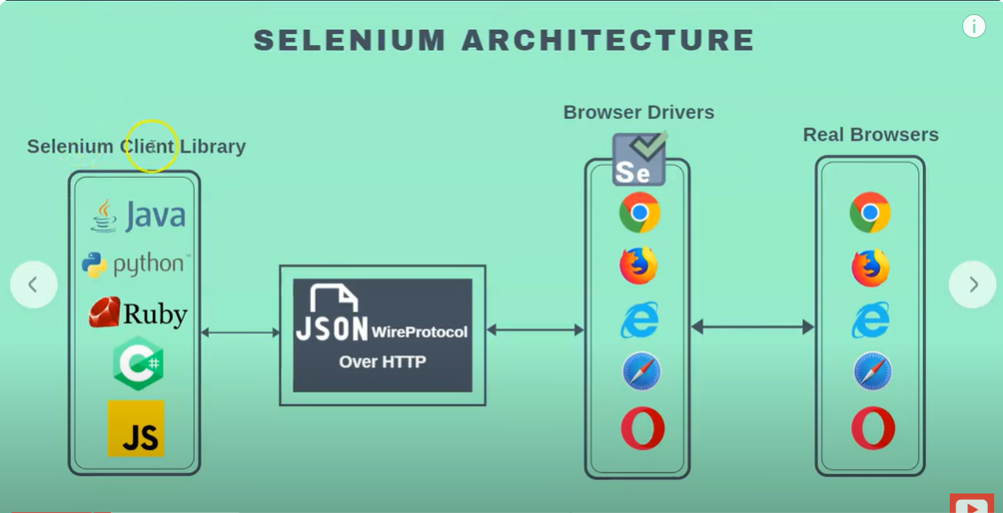

Steps to installation

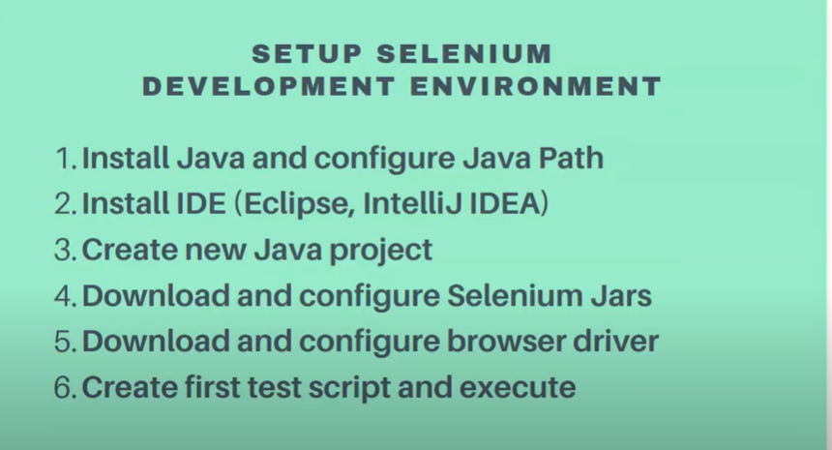

ECLIPSEis an editor- used for Java, Pycharm for python.

Create an new object of chromedriver.

<https://www.netguru.com/blog/test-automation-strategy-practices-and-examples>

Selenium JAVA Interview questions:

Equivalent Partitioning

Boundary value analysis – techniques for writing test cases.

Severity of bug- specified by testers.

Priority- by testers but possible po or anyone could change it.

Method – we can define and have diff parameters- has return type.

Constructors- should have same name as class name and has no return type.- initializing data into variables.

This keyword- this keyword always represents the class.- used when class variable names(global) and method variable names(local) are the same. This.x=x this.y== y.

Find elements – find all links – which locator to use? – tagname?

Find the total no of links- find length of web element? - .size

TestNG- reporting, parallel execution, grouping of test cases, validation, provide priority – execute priority based tets cases.

How to slip method/test case in test ng?

BDD – stories written in alanguage used understands.

TDD- test driven developemt